Intake Form for Esogetic Medicine
Answering these questions will help us understand what things are connected and how we can treat the whole. Share as much as you feel comfortable sharing with me. Some clients find they learn a lot by answering these questions. Some clients feel overwhelmed and prefer to just “get started”. We can fill in the blanks as we go. Feel free to send me “here is my answer to question #ABC”. I can populate the document on my end.
- What do you want to get out of working with me?

- What is your chief complaint? Describe your condition at it’s worst? If this goes unaddressed, how would it impact your quality of life?

- What have you tried in the past? What worked? What didn’t?

- Which healthcare practitioners are you currently working with and for what kind of treatments?

- What are your secondary complaints?

- Do you have any medical conditions? What severity (annoying, impairment, does it impact work or sleep, needs medication, hospitalization, surgery, etc.)?

- Please indicate on this image any areas of discomfort, pain, weakness, anomalies, where you tend to react, or hold emotions when under stress?
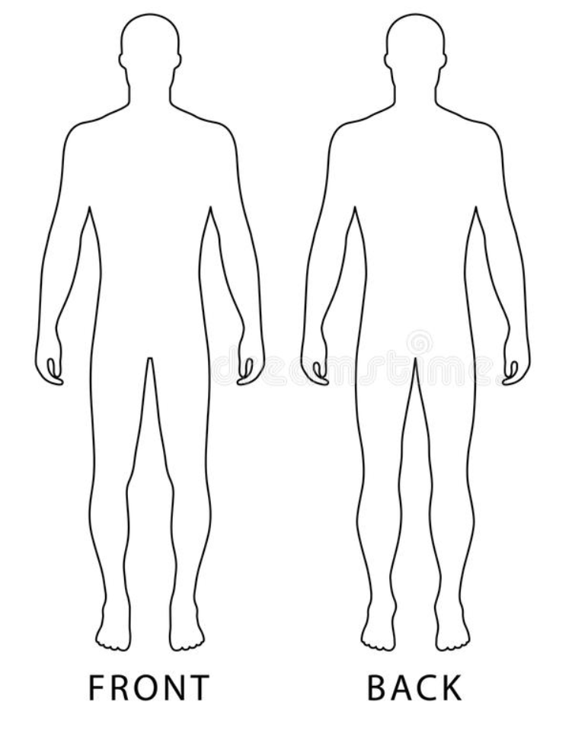
For each area marked above, list them in order of severity, when it began, and when you had previous episodes, frequency (20%-100% of the time), severity (annoying, impairment, does it impact work or sleep, need medication, hospitalization, surgery, etc.), type of discomfort (numbness, tingling, burning, pain, soreness, ache, stabbing, stiffness, scar), initial cause (if known), and if it is getting worse.

- Circle any acute or chronic symptoms (including those you may have become accustomed to) on the “Symptoms by Astrological Sign” document (available at the bottom of https://www.yhalp.ca/my-services). If you think it’s important for me to know, also fill out this form for your mother, father, spouse, siblings, and/or children.

- List current medications, vitamins, supplements, or recreational drugs (including alcohol, smoking, marijuana, etc.)?

- Do you engage in regular movement/exercise (none, light, moderate, active, very active, elite athlete)? Are you happy with this?
- Describe your relationship with your Mother – now and while growing up:
- Are you able to nurture and take care of yourself?

- Describe your relationship with your Father – now and while growing up:
- Are you able to take steps to be successful in the world?

- Were there others in your childhood who were important to you?
- Do you have children? How do you see your relationship with them?
- Describe your relationships in general (with friends, partners, peers, co-workers, clients, bosses, extended family, community, self, etc.) – now and while growing up:
- How far back can you remember (earliest age)? Do you have certain childhood memories that stick out for you, or that come back all of a sudden?
- Did you suffer from any abuse, psychological trauma, accidents, injuries, surgeries, neglect, or abandonment in childhood?
- Were you healthy as a child?
- Did you experience any accidents, surgeries, illnesses, traumas, major changes, loss, strong worries/stresses/fears during the following ages?
  - 0-3yrs
  - 3-6yrs
  - 6-9yrs
  - 9-12yrs
- Did you experience anything during puberty (age 12-24yrs) that allowed you to find yourself and heal your childhood wounds (a mentor, passion, caring person, etc.)?
- How was your mother’s pregnancy with you. If you don’t know, and she is still in your life, ask her. Did she have any prior miscarriages or abortions, did you have a twin that did not survive, how was your conception, how did your parents (and others) react when they found out they were pregnant, what was their life like at the 6 month mark, were there any complications with your water rupture, your time in the birth canal, your actual birth, the cutting of your cord, who was present in the room when you were born, were forceps, drugs, c-section, or other interventions used, or was there any stress before, during, or after your birth?

- Did your parents get along? Was there an underlying stress?

- If you have siblings, are they older or younger, what’s the age difference, how was the family impacted when you or they were born? What is your relationship with them now?
- Are you or have you ever been suicidal?

- Do you tend to react to your reactions?

- Are you maxed out and barely coping?

- Are you able to take time for yourself?

- Do you have someone you can talk to?

- Do you have some Unique Psychology guidelines you can follow?

- Do you have a hot water bottle (to place over your liver in case of any strong reaction)?

- Will you reach out to me for support if you have a strong reaction to treatment (either come in person to address it using Esogetic Medicine, or receive remote treatment using Divine Healing or the Information Field)?

- Are you open to adding RestoreChi, sound therapy, or other self-treatment (including journaling, Tarot, learning more about your Unique Psychology, or possibly borrowing Esogetic equipment to apply treatment between sessions)?
- What is your attachment style? For more information, see the “Attachment Styles” document at the bottom of https://www.yhalp.ca/my-services
- What is your go to when there is an absence of felt safety (watchdog, possum, poisonous cicada, squirrel, turtle, etc). Is it easy for you to shift out of this state and back into “owl” mode?
For more information, see the “Felt Safety Animals” document at the bottom of https://www.yhalp.ca/my-services
- Are you afraid to be your unique self? Do you get stuck in uncomfortable stress or emotion states? Can the different roles that you play co-exist easily, are they well integrated into the wholeness of who you think you are? For more information, see the “Kid-Friendly Emotions and Energy States” and “The Whole Brain Child” documents at the bottom of https://www.yhalp.ca/my-services
- How’s your sleep, any common waking times, do you wake rested, do you dream?
- Any allergies?
- Any addictions (substances or social/behaviours that you turn to to shift how you feel)?
- Any dental issues/procedures (i.e., cavities, gum issues, root canals, toothaches, mercury fillings, bridges, wisdom teeth removed, etc.)? If so, please indicate the specific tooth/teeth affected, and age, if you can.
- Any recurrent infections/illnesses in your lifetime (i.e., earaches, tubes in your ears, eye problems, sinus problems, tonsils, appendix, bronchitis, frequent flu, colds, digestive issues, etc.)? Indicate age, if you can.
- Any body parts removed, replaced, or other surgeries? Indicate age, if you can.
- Any hormonal problems in your lifetime (i.e., menstrual cycle, fertility, acne, adrenal, stress, sleep disturbance, menopause symptoms, etc.)? Any current hormonal treatment?
- Any learning or concentration problems (including neurodivergence, autism, gifted, rainforest mind, twice exceptional, asynchronous development, sensory processing issues, brain fog, dementia, etc.)? To learn more, see the “Sensory Processing Issues” document at the bottom of https://www.yhalp.ca/my-services
- Any back problems in your lifetime? If so, please indicate the type (including the specific vertebrae or section(s) affected, if you can), age, and resolution (if any).
- Describe your present home/family/work environment. Are you currently under any strong personal/professional stress? Any repeating stressors (especially across different situations/relationships)?
- Describe your main occupation. Are you happy with this?

- Do you feel you are on your true lifepath? Do you feel fulfilled with your life, or is something missing?

- Describe your diet (including appetite, thirst for water, cravings for sugar, salt, spice, etc.). Are you happy with it?

- Describe your current life force energy. Are you happy with it?

- Do you meditate, connect with your self regularly, or have a spiritual practice?

- What do you expect from this process?

Signing (or entering your name) below indicates that you understand that working with Alahnnaa Campbell of You Have A Life Plan is not intended as a replacement for medical treatment, advice, or your own common sense, and ability to determine what is right for you. This also indicates that you appreciate that it is your responsibility to seek medical care (or any other support) for any problems or illnesses:
Signature (or type name):
Date:

